︱AI -RH208 IR Lens CCTV Camera *SAMTECH*

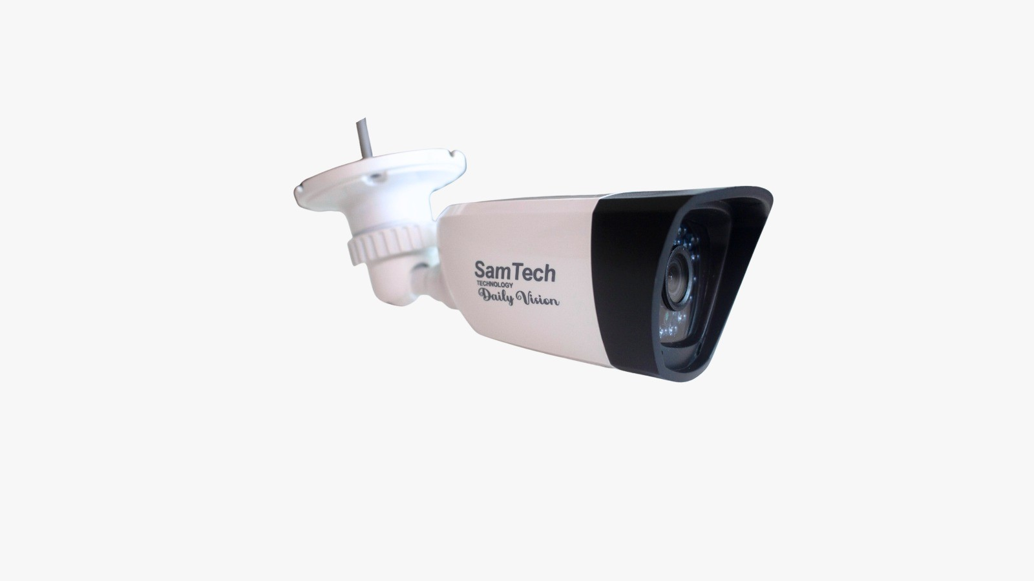

*Technology*

AI -RH208

3.0MP Full Night Vision Camera





|  |  |
| --- | --- |
| Model Number | AL-RH208 ( Water and Dust Proof ) |
| **Camera 3MP ( Water and Dust Proof )** | |
| Image Sensor | 1/3 Sony Super HAD CCD |
| Min. Illumination | Color: 0Lux/F1.2 (IR ON) |
| Lens | 4/6/8/12/16 mm (Optional) |
| Shutter Time | Auto |
| IR Distance | 25/35/60/100m |
| Effective Pixels | 976(H)x492(V) |
| White Balance | Auto |
| Video Output | <1.0Vp-p 75M+OMEGA |
| Wevelength | 850nm |
| Housing | Metal Bullet |
| Ultra high definition | Ultra high definition image sensor. |
| Three in One | Video/Audio/Control all in one composite signal |